PHASE 4
Testing Document

Midstream College Quiz Night

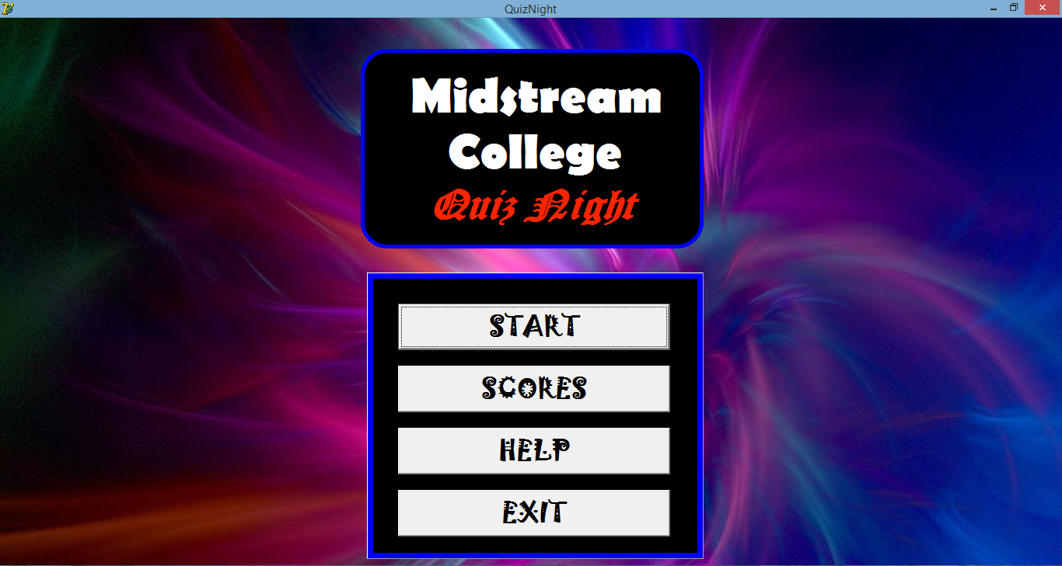

Developed by Bill Guo

Signoffs
Phase | Teacher | Date | Signature
4) Testing document | Mrs. Niebuhr

Fulfillment of features:
≪Copy all your features from the Specification document in and tick of whether your program can or cannot do it≫
Feature | Yes | No | Mostly

Specifications of Program Functions
- Get the participants of the particular grade doing the quiz night.
- Display the participants in their houses.
- Keep track of the houses score.
- Identify which house clicked the buzzer first and thereafter second.
- Retrieve the correct questions for the correct grade.
- Retrieve the correct answers for the correct grade.
- Have the correct subject headings every 5 questions.
- Have a timer.
- User can decide if answer is correct or wrong.
- Reset if a score is wrongly given.
- Identify the overall house winner at the end.
- Have a separate teachers interface since there are more teachers in a team.

Specifications of User Interface
- Front Cover will be for the cover for the event to begin.
- Grade Menu is to assign which grade’s turn is it or the teacher’s turn.
- Score sheet is to display the houses participants and their scores.
- Question is used to display the questions and answers with a timer.
- Number is used to get participants ready for the next question.
- Teachers is the teachers score sheet to accommodate them.
- Scores is to identify the overall house winner for the event.
- Help is to give help guidelines on how to use the program.

Specifications of Help
- A manual on how to go about with the program.
- A help form to see the guidelines on how to use the program.
- A help textfile if program cannot be run.
- Defensive programming so that programming will be relatively easy to use.

Specifications of Data Storage
- The Answers Folder contains: Grade 8-12.txt and Teachers.txt files.
- The Questions Folder contains: Grade 8-12.txt and Teachers.txt files.
- The Participants Folder contains: Grade 8-12.txt and Teachers.txt files.
- The Scores Folder contains: Grade 8-12.txt and Teachers.txt files.
- The Final Folder contains: House.txt file and Help.txt file.

Testing data:
Description of what is tested | Testing data | Results
If program can retrieve each grade and teachers participants from Grade Menu. | Textfiles with participant names in them. | All participants of each grade were displayed perfectly and neatly.
Keeping track of the different houses scores after every 5 questions. | Using buzzers to play around and answering questions. | Manually kept track of scores and the scores corresponded everytime.
Correct questions and answers were shown when Quiz Night was running. | Questions and Answers in different textfiles. | Questions and answers were successfully retrieved everytime and displayed.
Determining which buzzer was first and is fair. | Pressing all buzzer at different frequencies and at the same time. | Computer always gave a winning buzzer and arrows and numbers guide the user well.
Timer works. | Many different scenarios. | One error occurred where user cannot click on any edits when buzzers are activated or else setfocus is focused somewhere else. But got reset for timer to work again.
Saving scores. | Run a whole quiz night. | Scores were all saved and were proper and accurate.
Determining Final Score. | Adding up all the different scores of the grade and teachers. | A house winner was determined and sometimes a tie was reached.
Audience enjoyment. | Running this at Quiz Night. | Event was a success. Audience can keep track of what is going on.
User-friendly. | Let others use program. | Others found program very simple and easy to use.
After every 5 questions, the subject changes. | Tested with all grades’ questions. | Everytime after 5 questions, the section/topic changed.

